## 

ANDROID-Smart Travel Guide

**Table of Content**

|  |  |  |  |  |
| --- | --- | --- | --- | --- |
| **Group Members** | | | |  |
| **Acknowledgement** | | | |  |
| **Table of Content** | | | |  |
| 1. | **Introduction** | | |  |
|  | 1.1 | | Problem Statement |  |
|  | 1.2 | | Requirements |  |
|  |  | |  |  |
| 2. | **Application Description** | | |  |
|  | 1  2 | Features  UI | |  |
| 3. | **Task Sheet** | | |  |
| 4. | **Conclusion** | | |  |

**Group Members**

|  |  |
| --- | --- |
| **Name:** | Muhammad Faizan Sarwar (Student1254896),  Muhammad Ahmer Iqbal (Student1256206),  Maryam Mehmood Muccadam (Student1231818),  Mohammad Mujtaba (Student1240030) |
| **Batch Code:** | 2001G2 |
| **Faculty:** | Sir Noman Qadir |
| **Coordinator:** | Miss Iqra |

**Acknowledgement**

**First of all, we would like to thank Almighty Allah who praised us with the ability to think, work and deliver what we were assigned to do. Secondly, we must be grateful to our teacher Sir Noman Qadir who helped us throughout this project with his constant supervision and support. He has been there to lend his sincere support and advice at all times and has given us invaluable advice, inspiration and suggestions in our journey of knowledge. He gave us the right guidance that has led us to the completion project of. Without his wise advice, this project would not have been possible.**

**We would also like to express our gratitude to our course coordinator Ms. Iqra for her trust, support and valuable advice throughout the project.**

**We are highly indebted and thankful to Aptech for giving us this challenging project as a part of our studies and giving us a chance to prove ourselves.**

**Lastly, we would like to express our gratitude towards our parents & to each other without the co-operation and encouragement completion of this project was impossible.**

1. **Introduction**
   1. **Problem Statement**

**ANDROID - Smart Travel Guide**

The number of people going out on tours and recreation has increased over the years. An Android application for smart travel guide is designed in this project. The purpose of this application is to provide tourism-based information to the user very conveniently.

EXISTING SYSTEM

In the tourism industry, tourist information is obtained mainly through newspaper, magazines, radio and other simple ways those are available easily. But problem is that tourists are not able to get travel information timely when they are on the move. While today&#39; s mobile devices are becoming more intelligent, compared with PC, they still have the following limitations like small screen and tiny keyboard, limited CPU capacity, limited memory space, slow and fitful Internet connection. Many mobiles of recent decades have travel guide application. But the application on these mobiles work slow due to continues acquisition of the bandwidth. Therefore, the mobile end-user’s operation is very difficult, and the contents display on the screen of mobile device is limited.

PROPOSED SYSTEM

There is greatly enriched travel information provided to the tourists on the Internet. However, a problem is shown that tourists are not able to get travel information timely when they are on the move. Therefore, we intend to build a mobile tourist guide system based on Android App technology to solve this problem. The main objective of the app is when users are on the move, it is able to provide rich and concise information timely and make them access to the service at anytime and anywhere.

**KEY FUNTIONALITY**

* Find Current Location
* Locate in Map
* Calculate Distance between two Cities
* Video Search
* Weather Forecast
* Information upon the tourist spot.
  1. **Requirements**

**Hardware**

* Android mobile with a minimum version 2.2.
* The processor is not less than 500MHZ.
* RAM is not less than 2048MB.
* SD card with a minimum of 512MB.
* Resolution is not less than 480*800pixs.

**Software**

* Use software as per your requirement
* Windows OS/JAVA/Android SDK/Notepad/SQL/Android 2.2 or Later

**2.2 UI**

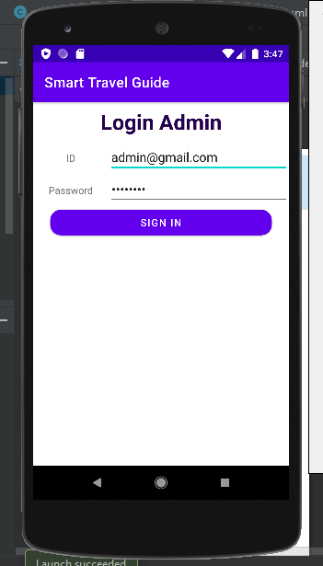

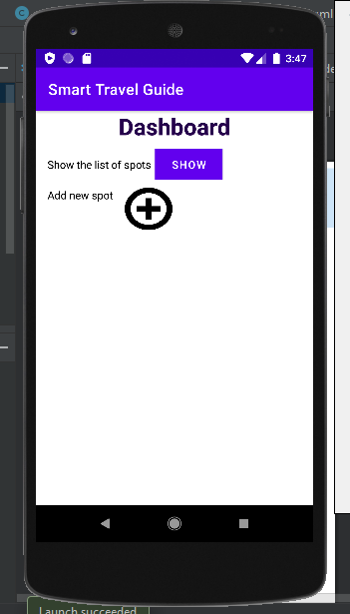

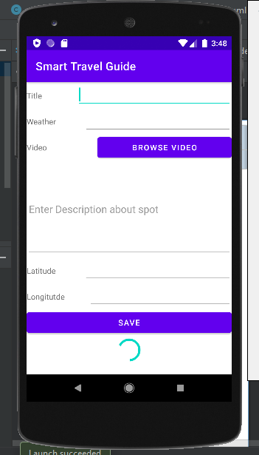

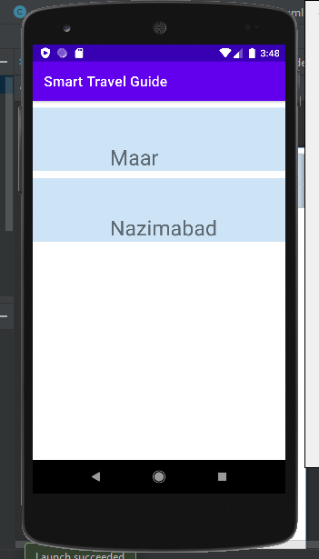

1. **Task Sheet**

|  |  |  |  |  |  |
| --- | --- | --- | --- | --- | --- |
| **No.** | **Task** | **Actual Start Date** | **Actual Days** | **Team Mate Name** | **Status** |
| 1. | Analysis | 8-1- 2022 | 10 | All Members | Completed |
| 2. | Data Collection | 13-1-2022 | 10 | Maryam Mehmood Muccadam | Completed |
| 3. | Interface  Designing | 29-2- 2022 | 5 | M. Ahmer Iqbal | Completed |
| 4. | Testing | 5 -2-2022 | 5 | M. Ahmer Iqbal & M. Faizan Sarwar | Completed |
| 5. | Documentation | 13-2-2022 | 2 | M. Faizan Sarwar | Completed |

**4. Conclusion**

This overall project was bit challenging for us, but we have given our best and with the proper guidance of our instructor we have successfully completed this project in the given duration. This has helped us to boost our skills of building an app and we have learned a lot from it. Many challenges were faced during the development of this app, but with proper management, guidance and team work we are able to do it.